E-Book on “ Is it a Challenge or an Opportunity?”

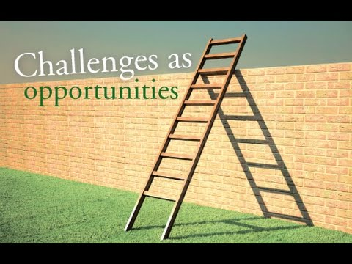

Challenges are difficult and literally challenge our beliefs, actions, our responses, our core values...They make us think, evaluate, feel uncomfortable….many people see this as a negative, or bad thing - like a punishment. How do you view challenges?______________________
______________________________________________________________
How do you view opportunities?___________________________________
_______________________________________________________________
What connection might you see between the two?__________________
______________________________________________________________
Have challenges have you had?__________________________________
_______________________________________________________________
What opportunities have you had?________________________________
______________________________________________________________
How can you see any of your challenges transform into opportunities for you?____________________________________________________________
________________________________________________________________
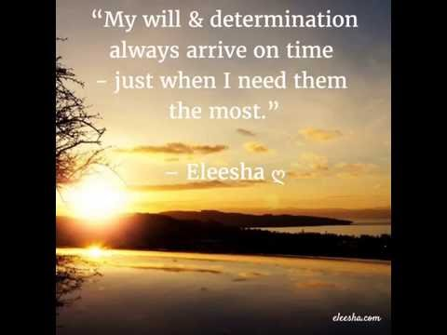

We do have to pick up our crosses and follow Jesus, but not as a punishment, or make us suffer, but crosses, or challenges are meant to have redemption, saving grace, or an offering of self-giving for others...others might view the description of a challenge of an opportunity to evaluate, assess, see where movement and actions can occur.
Some people see problems….others see solutions….opportunity to grow, gain insight and vision, makes changes that serve you, and reach a new goal. How might seeing challenges as opportunities vs. blocks benefit you?___________________________________________________________
_________________________________________________________________

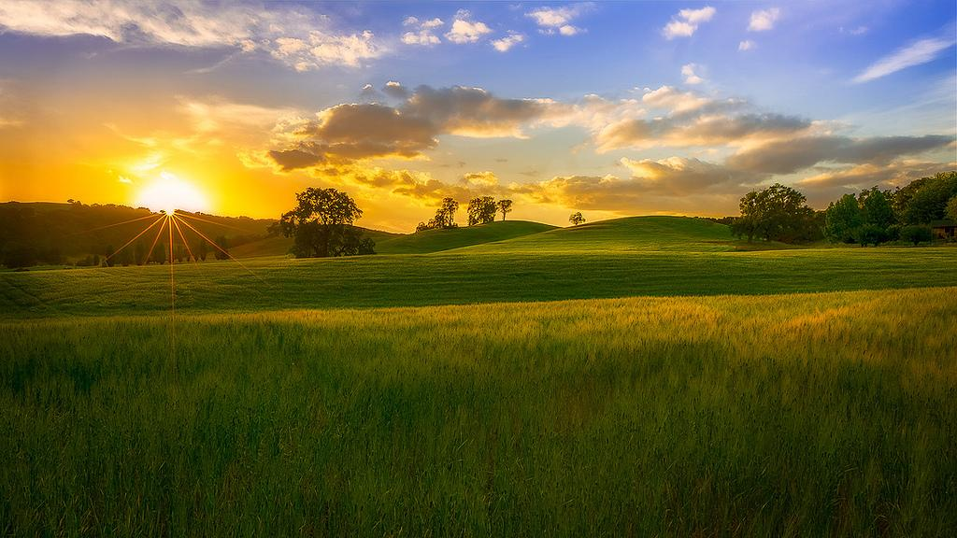

What do you imagine to be the best thing to come out of this new perception?________________________________________________________
_________________________________________________________________
How can this allow you to grow in action and movement forward?_______
__________________________________________________________________
How might this influence others around you?_________________________
_________________________________________________________________
What is your take on this idea?_____________________________________
__________________________________________________________________
What are some thoughts you can have to support a new way of thinking?__
__________________________________________________________________
How might you want to feel when viewing challenges as solutions?_______
__________________________________________________________________
What kind of actions can you take to feel what you want?_______________
__________________________________________________________________
How are these actions different than what you might be doing now?_____
_________________________________________________________________
What/who can support you in your new attempts?_____________________
__________________________________________________________________

How willing are you to make this a reality on a scale of 1-10, 1 being the least likely?____________________________________________________
If you are a 10-describe how that will look in action, if not what will it take to move up a number?______________________________________________
__________________________________________________________________
Desired outcomes take effort and determination, but above else, trust in God and His unending love for you and your ability-and your final outcome!!

He believes in you and loves you profoundly!!
Congrats for contemplating healthy changes in your life and taking on challenges as opportunities to success and live in abundance!!
Please visit my website www.findinggodspeace.com or email me at www.gina@findinggodspeace.com for questions or opinions!! I value you and know that all you need to know lies within you and the Spirits living witness in your life!!
