Online course on “How can Knowing and Living the Beatitudes make ME Happy and Joyful?”
7th part of the 8 part series.

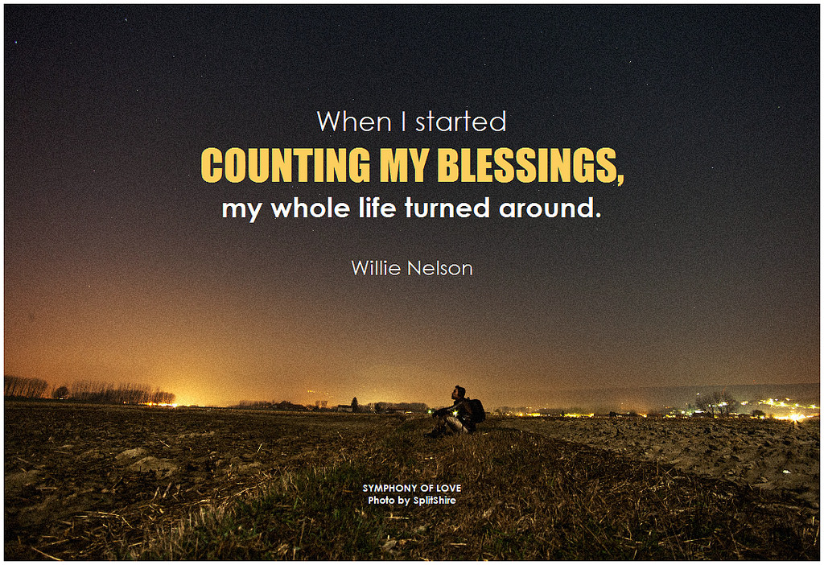

Welcome back to our seventh part in this amazing series/journey on finding joy and peace in your daily living by knowing and being a witness to the 8 Beatitudes.

An overview of our time together: THE EIGHT BEATITUDES OF JESUS

"Blessed are the poor in spirit,
for theirs is the kingdom of heaven.

Blessed are they who mourn,
for they shall be comforted. We will look at each one separately
Blessed are the meek,
for they shall inherit the earth.

Blessed are they who hunger and thirst
for righteousness,
for they shall be satisfied.

Blessed are the merciful, We will explore ways to live them out
for they shall obtain mercy.

Blessed are the pure of heart,
for they shall see God.

Blessed are the peacemakers,
for they shall be called children of God. We will look at how this feels for you

Blessed are they who are persecuted for
the sake of righteousness,
for theirs is the kingdom of heaven."

Gospel of St. Matthew 5:3-10

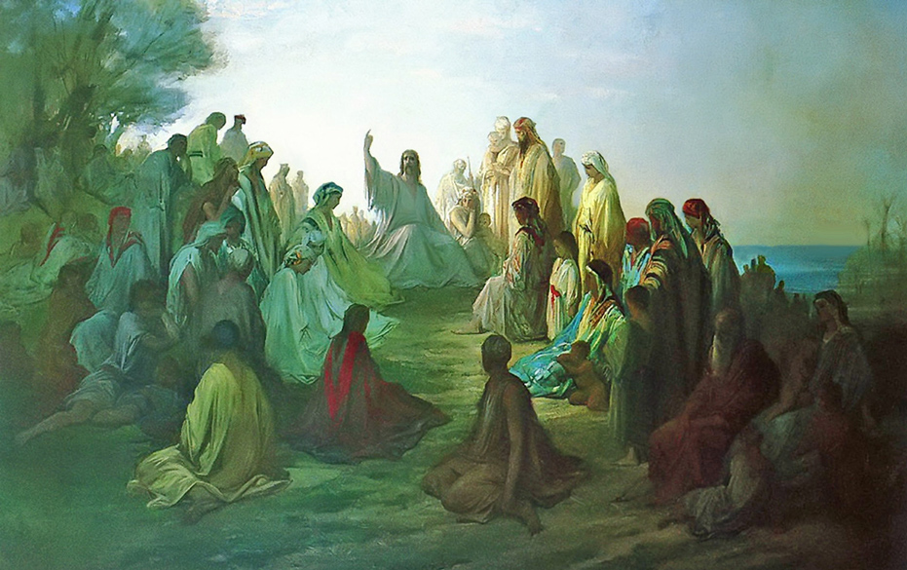

“Blessed are the peacemakers,
for they shall be called children of God.”
What does being peaceful mean to you? How does look and what do you feel? We all have our own ideas of versions of what peace is all about especially if we base it off of prior experiences and perceptions.

The definition of peace is freedom from disturbance; quiet and tranquility. Some synonyms are tranquility, calm, restfulness, peace and quiet, peacefulness, quiet, quietness.

It is funny that being quiet, still, calm, and maybe even being alone is construed as peaceful. It is in that stillness in our bodies, hearts, and minds that we can really begin to hear a lot of things, that we usually cannot focus on. We hear the Word of God (revelation), inner wisdom and grace flooding us, meditation and being able to pay attention to our surroundings -like birds chirping, leaves rustling, or water moving. We can allow ourselves the time to listen to our bodies (whether things we concerned about that we don’t have time or energy to confront, or our dreams, hopes, and being able to re-assess our values and priorities.

It is a peace within our heart, that we can let go of hurt, resentment, hatred and anger, and mistrust. It is a peace that transcends logic and evidence, but rather a peace that is so overwhelming that those feelings overpower any doubt or anxiety out there.

It takes practice to achieve this peace only offered to us by God, the world cannot give it or fill the void that yearns for it. ( John 14:27). It takes faith knowing one will and can achieve it, discipline to not give in to the supposed treasures of this world that mask the Truth.

Peace is a common thread that many fight for, toil after, and weep for. That peace, though, is always in our midst and reach. We must become more conscious of it and sit in that stillness to really hear and feel the peaceful presence of the Lord. through this peace, can we have everlasting joy!

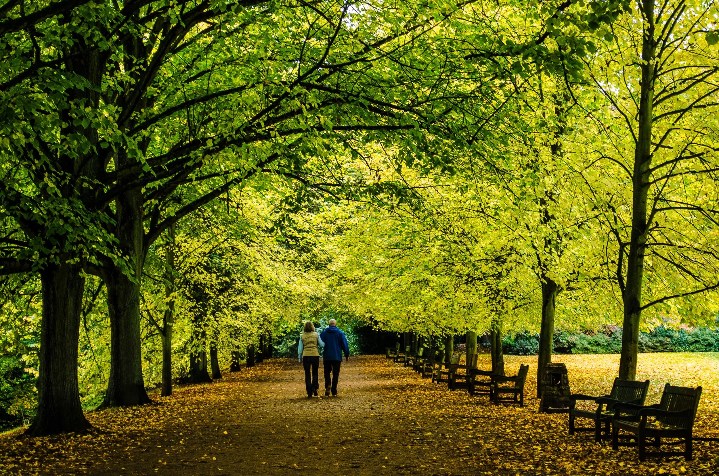
How can you challenge your old perceptions of peace? Have your old beliefs work for you? How can you use that information to learn and grow for what you really want?
Do you value peace? To what extent? What level of commitment are you ready to take on in order to fulfill your need to have peace in your everyday life, not just on vacations?

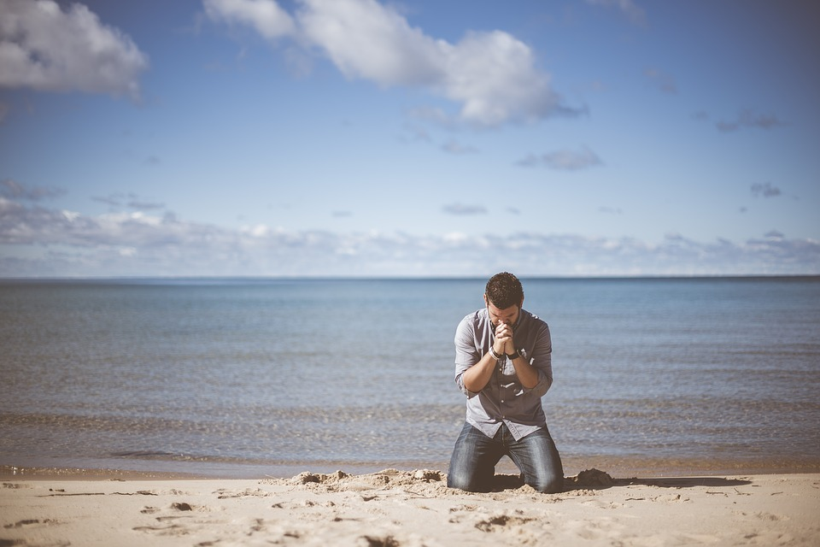

How can you live this idea out?
How can you make this your call to action today? Tomorrow? Not necessarily all the time, but start to seek it even a little bit a time. Are you willing to further explore how this can look and work in your life?

I am here to partner with you on your journey to finding God’s peace within, who you were designed to be, let your gifts come to life, live in abundance, and allow peace and joy to be yours!!

Thanks so much for diving deeply into this 7 of 8 part series on the Beatitudes. I know you care about your life and value how truly precious you are to Him!!

Can’t wait to see you next time for “Blessed are they who are persecuted for the sake of righteousness, for theirs is the kingdom of heaven."

Please visit my site at www.finddinggodspeace.com or email me at

​ Gina@findinggodspeace.com for questions or thoughts!!

